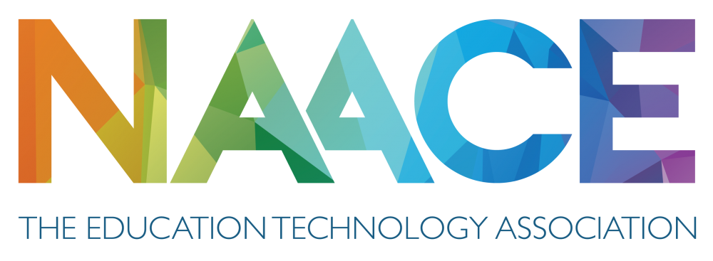
Internet ballot: nomination form
Member of the Board of Management

Please read the information found at https://naace.org.uk/elections/. This form should be completed by those offering themselves as candidates for ONE vacant position (of a total of FOUR) on the Board of Management, seeking to serve for a period of four years (subject to the rules of the association). The ballot will take place between 6:00pm on Wednesday 20th December 2023 and 6pm on Wednesday 10th January 202 with the results being announced on the Naace website on (www.naace.org.uk) Thursday 11th January 2024 and confirmed on Monday 5th February 2024 at the AGM.

Please PRINT your name:

Full name:

I, the undersigned, wish to offer myself as a candidate for the position of Member of the Board of Management to serve from January 2024 and if elected, agree to abide by all relevant legislation and the regulations regarding office laid out in the Articles, Memorandum and Rules of the Association.

Signed: | Date:

The members proposing and seconding the candidate should complete below:
Proposer | Seconder
I the undersigned, confirm I am a fully paid up member of the Association and wish to propose the person named above as a candidate for the position of Member of the Board of Management. | I the undersigned, confirm I am a fully paid up member of the Association and wish to second the person named above as a candidate for the position of Member of the Board of Management.
Signed:  Print name: | Signed:  Print name:

Email completed versions of this form to elections@naace.org.uk.
We will accept individual emails from candidates, proposer and seconder.
The deadline for the receipt of nominations is noon on Wednesday 20th December 2023.

Please Note: Candidates are also requested to submit a supporting statement no longer than 400 words and a recent photograph (.jpg or .png) by sending copy via email to elections@naace.org.uk

